Week 2: SOC Alert Management, Incident Response, and Threat Analysis

Niraju Ginoya
Soc Week-2
Task 1

1)Alert Priority Levels
In a Security Operations Center (SOC), many security tools such as SIEM, EDR, firewalls, and IDS generate alerts every day. These alerts can range from harmless system messages to serious cyberattacks.
Because SOC analysts cannot investigate every alert at the same time, alert priority levels are used to decide which alerts must be handled first.
Alert prioritization ensures that Critical threats are addressed immediately,Business operations are protected,Soc resources are used efficiently,False positives and low-risk alerts do not waste time.
SOC environment, alerts are usually classified into four priority levels:
- Critical
- High
- Medium
- Low

Critical Priority
In a Security Operations Center (SOC), "Critical Priority" (often P0 or P1) signifies incidents demanding immediate, all-hands-on-deck attention, like ransomware on servers or data breaches involving sensitive information, as they pose severe threats to core business functions, data, or compliance, requiring rapid response to prevent major disruption or financial loss.
Characteristics
- The attack is actively happening
- There is a very high risk of data loss
- Systems may become unavailable
- Immediate response is required to prevent further damage.
Examples
- Ransomware encrypting production servers
- Data exfiltration from a customer database
- Log4Shell exploit detected on an internet-facing server
  - CVSS score: 9.8
  - Remote code execution possible.
- Breach of customer or financial databases.

High Priority
In a Security Operations Center (SOC), "high priority" refers to critical security incidents demanding immediate action, like active breaches or system outages, often categorized as P0/P1 and prioritized over less urgent issues to prevent major disruption, data loss, or business halt, using triage to quickly filter alerts and focus resources on genuine threats.

Characteristics
- Strong indicators of compromise are present
- Attack attempt is detected
- Privileged accounts or sensitive systems may be involved
- No confirmed data loss yet
Examples
- Unauthorized administrator login detected.
- Malware detected but execution was blocked.
- Privilege escalation attempt on a server.

Medium Priority
In a Security Operations Center (SOC), "medium priority" (often P2) signifies alerts with moderate urgency and impact, meaning they aren't critical system outages (P0/P1) but still pose significant risk, requiring thorough investigation sooner than low-priority (P3/P4) issues to prevent larger attacks or data loss, focusing on potential feature malfunctions or unusual activity that needs timely review.
Characteristics
- Limited access or impact
- No confirmed exploitation
- Often related to policy violations or abnormal behavior
Examples
- Multiple failed login attempts
- Malware detected on a test or lab machine
- Suspicious PowerShell execution with no damage.

Low Priority
In a Security Operations Center (SOC), a "low priority" incident or alert is an event that has a minimal immediate impact on business operations or data security and does not require urgent action. These items are placed in a backlog and addressed when higher-priority tasks are complete, often during regular business hours.
Characteristics
- No attacker activity confirmed
- Normal or expected system behavior
- Minimal or zero security risk

Examples
- Port scans blocked by firewall
- Antivirus signature update notifications.

Wazuh Dashboard Image

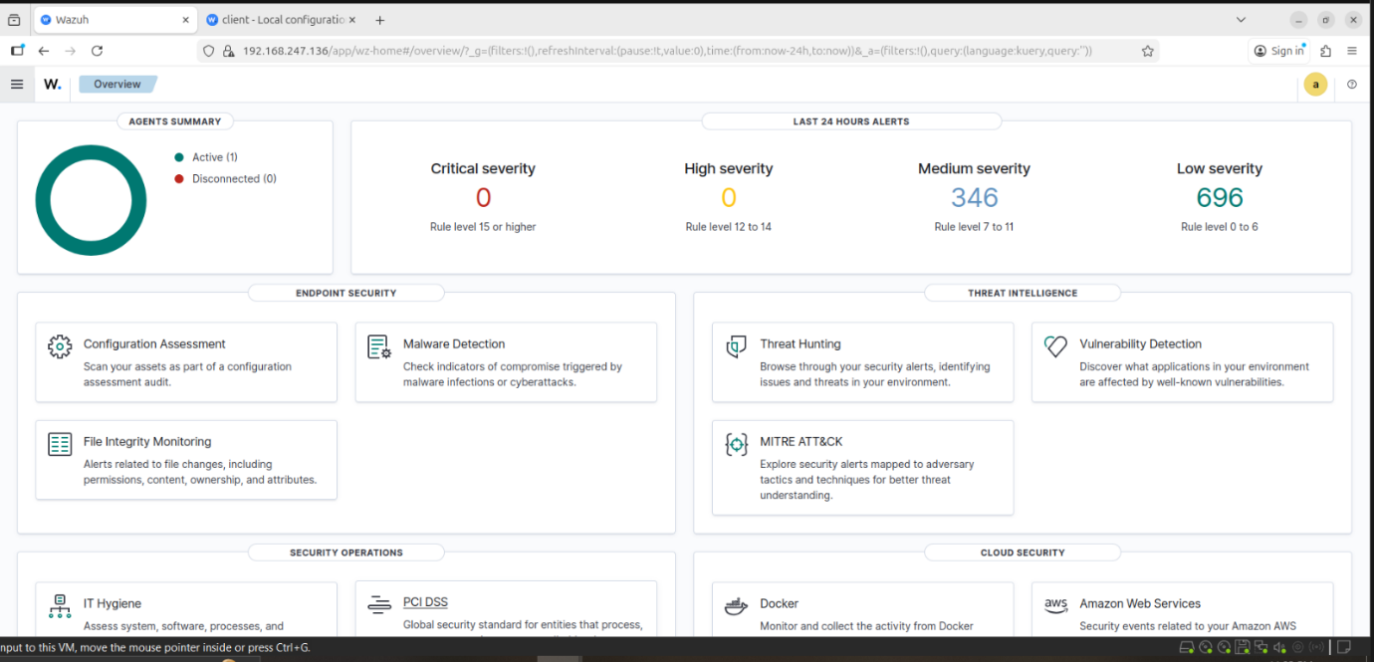

CVSS System
The Common Vulnerability Scoring System (CVSS) is an open, standardized framework for assessing and communicating the severity of software vulnerabilities, primarily to help a Security Operations Center (SOC) prioritize remediation efforts. It provides a numerical score (0.0 to 10.0) and a vector string based on a vulnerability's characteristics.
- 0 = No risk
- 10 = Extremely dangerous

CVSS Severity Levels:-

CVSS Score | Severity | Meaning
0.0 | None | No security impact
0.1 – 3.9 | Low | Minimal risk
4.0 – 6.9 | Medium | Moderate risk
7.0 – 8.9 | High | Serious risk
9.0 – 10.0 | Critical | Extremely dangerous

ALERT CLASSIFICATION (GOOGLE SHEETS)
This is SOC documentation work, done from VM1 browser.

Create Alert Classification Sheet
Create a Google Sheet with this table:
Alert ID | Alert Name | Source VM | Rule Level | Priority | MITRE
001 | SSH Brute Force | VM2 | 10 | Medium | T1110
002 | Port Scan | VM2 | 3 | Low | T1046

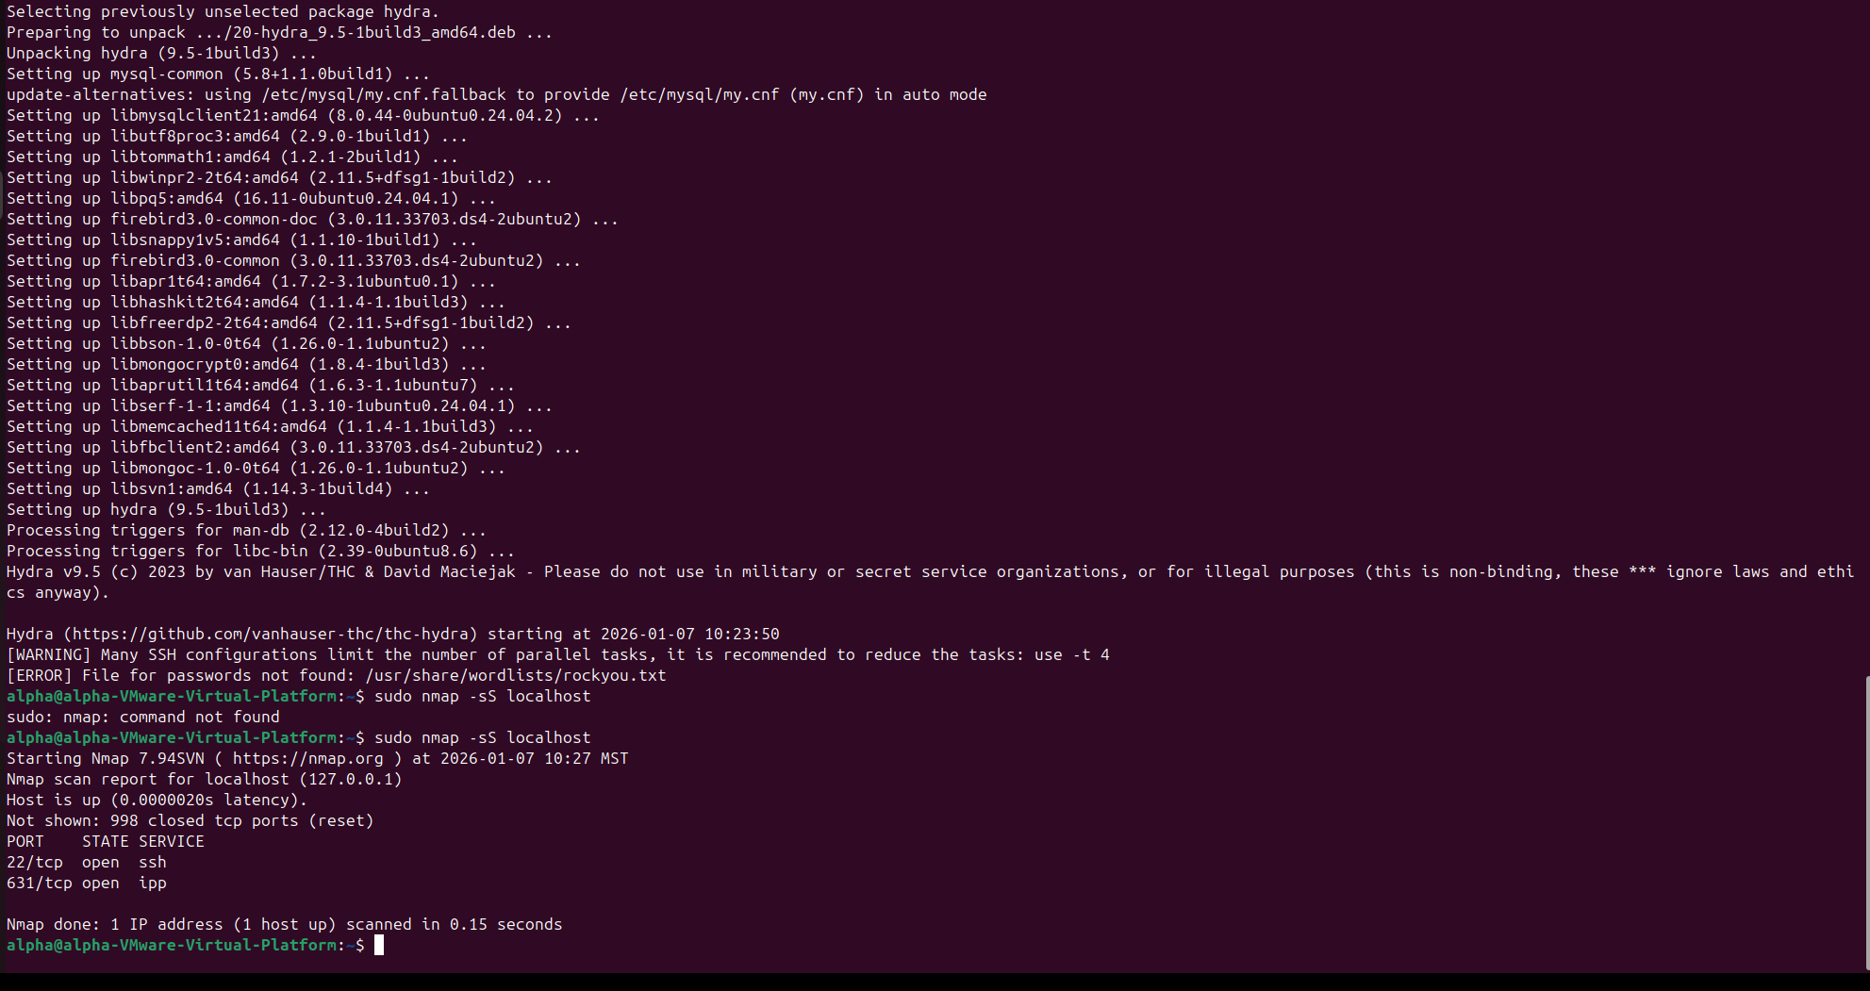

2) Incident Classification
Incident classification is the process of identifying and categorizing security incidents based on their nature and impact. Common incident categories include malware, phishing, DDoS, insider threats, and data exfiltration. SOC analysts use standardized frameworks such as MITRE ATT&CK, ENISA Incident Taxonomy, and VERIS to label incidents consistently.
Additionally, incidents are enriched with contextual metadata like affected systems, timestamps, source IPs, and indicators of compromise (IOCs). Proper classification and enrichment help streamline investigations, improve response accuracy, and enhance SOC efficiency. Standardized frameworks are used to ensure uniform classification across organizations. The MITRE ATT&CK framework maps incidents to attacker tactics and techniques, such as T1566 for phishing, providing insight into adversary behavior. Other taxonomies like ENISA and VERIS offer structured approaches for recording and sharing incident information. In addition to classification, incidents are enriched with contextual metadata such as affected systems, timestamps, source IP addresses.
Incident Categories
1. Malware Incident :- Malicious software detected.
2. Phishing Incident:- Fake emails or messages to steal credentials.
3. DDoS Incident:- Flooding a server with traffic to make it unavailable.
4. Insider Threat:- Attack or misuse by an employee.
5. Data Exfiltration:- Sensitive data stolen and sent outside.

Standard Taxonomy Frameworks
1.Mitra Attack:- Describes how attackers perform attacks.
2. Enisa Incident Taxonomy:- Classifies incidents at organizational and national level.
3. Veris Framework:- Standard vocabulary for incidents.

Contextual Metadata (Incident Enrichment)
Metadata = Extra details that make investigation easier.

Common Metadata Used in SOC:
Metadata | Example
Affected system | Employee laptop
Timestamp | 07-Jan-2026 10:30 AM
Source IP | 192.168.1.10
Destination IP | 45.33.22.10
IOC | Malicious hash
User | employee@company.com

Incident Ticket – SSH Brute Force Attempt
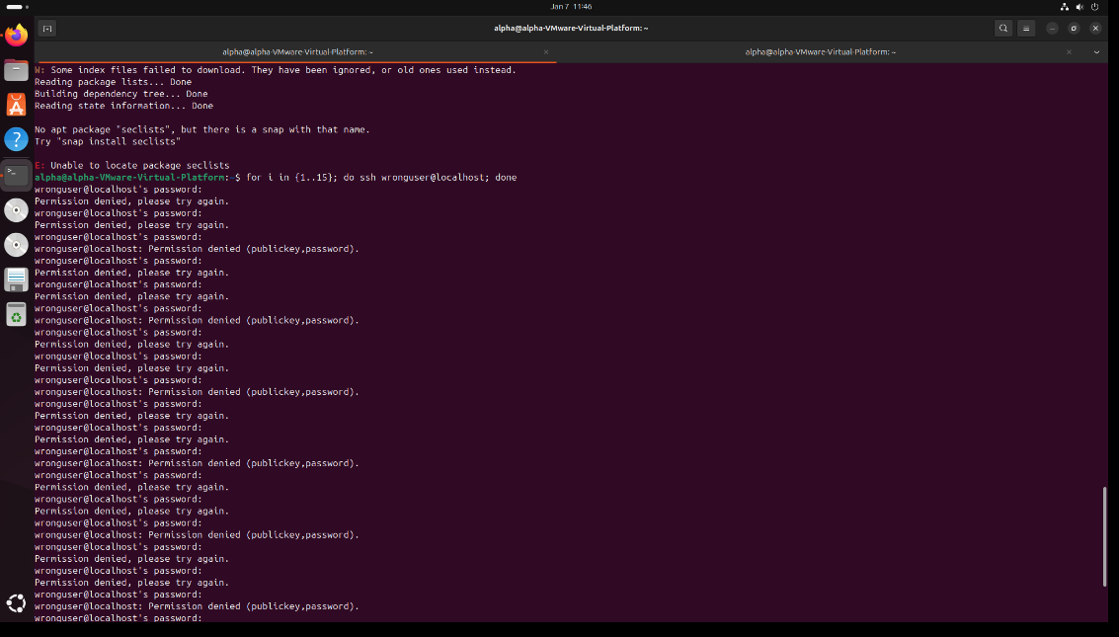
3) Basic Incident Response
Incident Response (IR) is a structured approach used by cybersecurity teams to detect, analyze, contain, and recover from security incidents such as malware infections, unauthorized access, data breaches, and denial-of-service attacks. The primary goal of incident response is to minimize damage, reduce recovery time, and ensure business continuity while preserving evidence for investigation and compliance purposes. A well-defined incident response process is critical for organizations to effectively manage security threats in a timely and controlled manner.

Incident Response Lifecycle
The incident response lifecycle provides a systematic framework for handling security incidents. This lifecycle is defined in standards such as NIST SP 800-61 and is widely followed by Security Operations Centers (SOCs).

1. Preparation
Preparation involves establishing policies, procedures, tools, and resources before an incident occurs. This phase ensures that the organization is ready to respond effectively to security incidents.
Key activities include:
- Developing incident response policies and playbooks
- Defining roles and responsibilities of the incident response team
- Deploying security tools such as SIEM, EDR, and SOAR platform
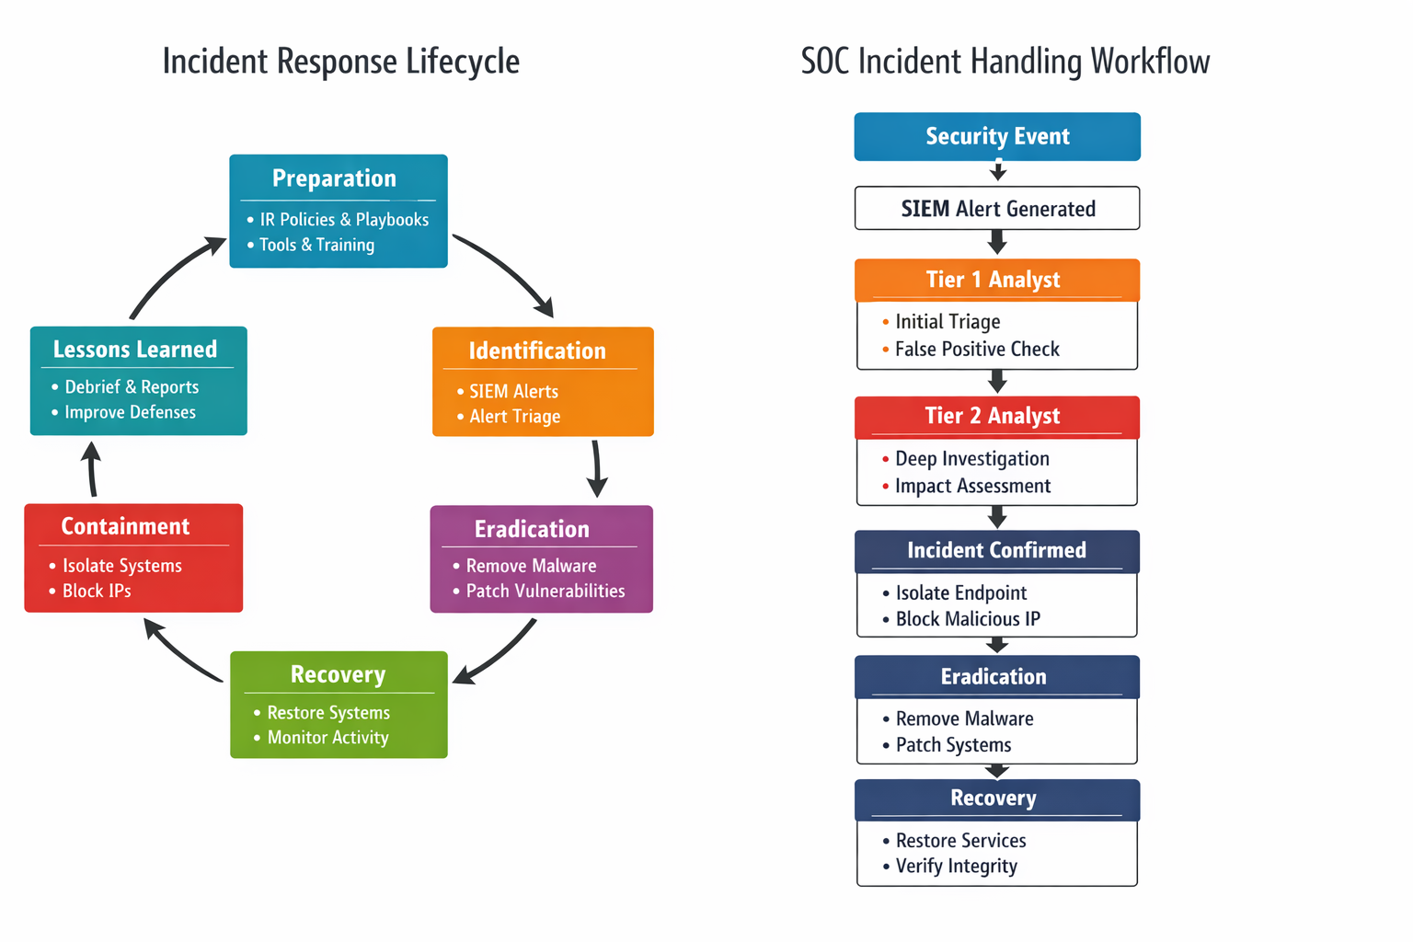
2. Identification
Identification is the phase where a potential security incident is detected and analyzed to determine whether it is a true incident or a false positive.
Key activities include:
- Monitoring alerts from SIEM, IDS/IPS, EDR, and security tools
- Performing alert triage and initial analysis
- Correlating events to identify attack patterns
- Classifying incidents based on severity and impact
Accurate identification is crucial to avoid unnecessary actions and to prioritize high-risk incidents.

3. Containment
Containment focuses on limiting the spread and impact of the incident. The objective is to prevent further damage while maintaining evidence integrity.
Key activities include:
- Isolating affected systems from the network
- Blocking malicious IP addresses or user accounts
- Disabling compromised credentials
- Applying temporary fixes or segmentation controls
Containment strategies are often divided into short-term containment (immediate actions) and long-term containment (temporary solutions until eradication).

4. Eradication
Eradication involves removing the root cause of the incident and eliminating all malicious components from the environment.
Key activities include:
- Removing malware, backdoors, or malicious files
- Patching vulnerabilities exploited during the attack
- Updating security configurations and access controls
- Ensuring that threat actors no longer have access
This phase ensures that the threat is completely eliminated before recovery begins.

5. Recovery
Recovery focuses on restoring affected systems and services to normal operation in a secure manner.
Key activities include:
- Restoring systems from clean backups
- Monitoring systems for signs of reinfection
- Validating system integrity and functionality
- Gradually reconnecting systems to the production network

6. Lessons Learned
The lessons learned phase is conducted after the incident is fully resolved. It aims to improve future incident response capabilities.
Key activities include:
- Conducting post-incident reviews and root cause analysis
- Documenting timelines, actions taken, and outcomes
- Identifying gaps in controls, tools, or procedures
- Updating incident response plans and playbooks
- Implementing security improvements and preventive measures
This phase strengthens the organization’s security posture and helps prevent similar incidents in the future.

Incident Description
Multiple failed SSH authentication attempts were detected on the endpoint system (VM2). The Wazuh agent identified repeated password failures through the SSH daemon, indicating a potential brute-force attack targeting the SSH service. The event was generated from system logs monitored via journald and decoded by the SSHD decoder.

Incident Timeline
Time (IST) | Action
18:46 | Wazuh detected multiple SSH authentication failures
18:47 | SOC analyst reviewed and triaged alert
18:50 | IOC validation performed
18:55 | Incident classified as true positive
19:00 | Incident documented and closed

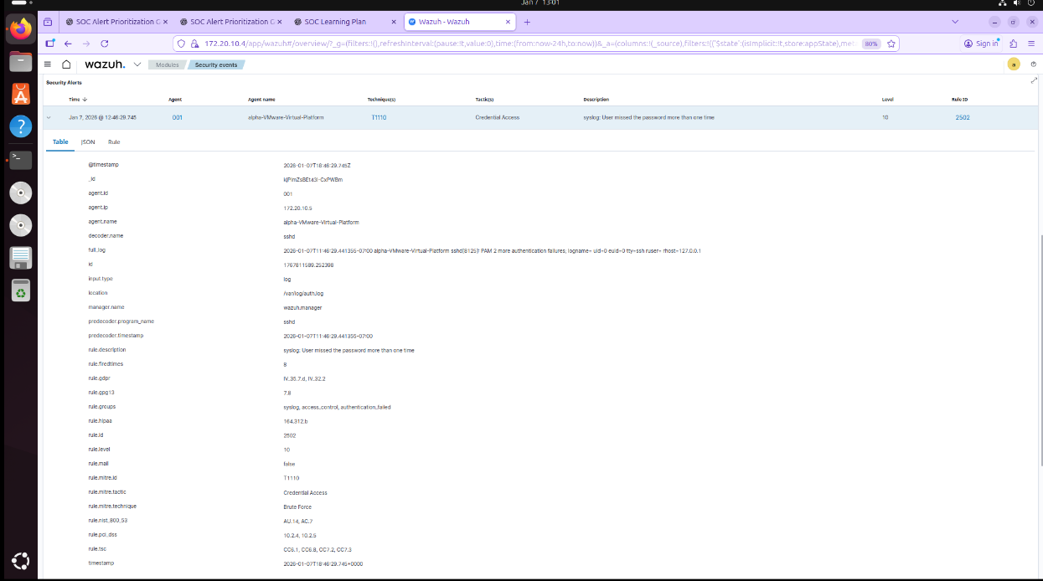
Threat Intelligence Validation – VirusTotal
In this step, the source IP address detected in the Wazuh SSH brute-force alert was analyzed using VirusTotal to determine whether the activity was malicious or a false positive. VirusTotal aggregates threat intelligence from multiple antivirus engines, security vendors, and community feeds.

The IP address was searched in VirusTotal, and the analysis results were reviewed for malicious detections, abuse reports, and historical behavior. The scan results helped confirm whether the IP was associated with known brute-force attacks, botnet activity, or suspicious behavior.

This validation step allowed the SOC analyst to make an informed decision on alert severity and response actions. If the IP had been flagged as malicious, immediate containment and blocking would be required. If not, the alert could be classified as low risk or a potential false positive.

